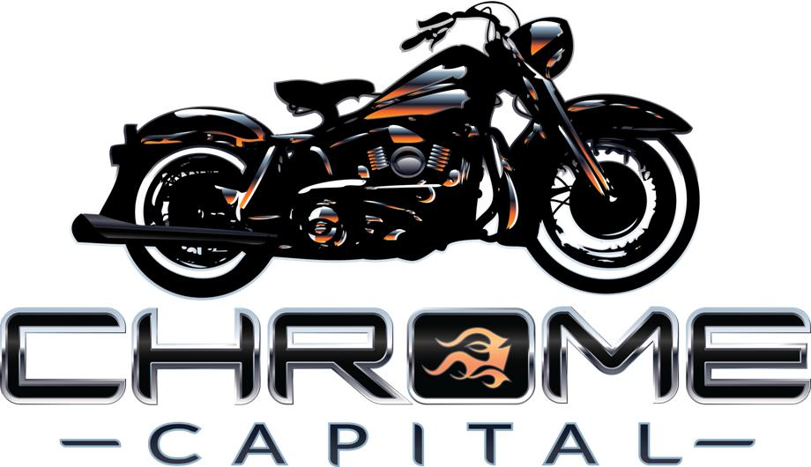

CORPORATE BACKGROUNDER

CHROME CAPITAL LLC
A Company Hitting On All Cylinders.

NAPLES, FL -- Chrome Capital LLC, is a company launched as a result of a personal passion. It’s a company started in 2011 by avid Harley-Davidson® riders, to provide a service that allows riders to lease Harleys without mileage limits and for no money down.

It’s CEO and founder, Peter Wasmer, combined his experience in business equipment leasing and a love for Harleys, to create a company that is changing the way motorcycles are financed in America.

Wasmer discovered a few common obstacles to getting on a Harley, that demanded an alternative solution to long-term loans. He compiled a team of industry leaders from the top Harley-Davidson® dealers in the world and the top financial partners in the country. The management team has combined experience of over 110 years in related industries.

Chrome Capital has made large investments in technology and man-hours developing a proprietary system for calculating payments and residual value of motorcycles over various lease periods. According to Wasmer, one of the reasons that the business model for the company is so attractive is that Harley-Davidsons tend to hold their value very well. When Chrome Capital leases a Harley it becomes an asset of the company that depreciates very slowly, resulting in an attractive balance sheet.

Chrome Capital has grown very quickly. Since 2011, more than 580 Harley-Davidson and independent dealerships have signed-up to offer leasing. The idea of vehicle leasing, widely accepted in the automotive industry for 25 years, is gaining traction in the motorcycle community.

According to Wasmer, motorcycle riders are even more fickle than car buyers, when it comes to trading and upgrading. He said that research and direct experience indicates that riders start searching for a new bike after just two years. That is contradictory to the traditional loan agreement that includes a commitment of five to seven years. With the Chrome Capital lease of two to four years, riders can trade without any negative equity in a shorter period of time. And dealers get a guaranteed and more frequent repeat customer.

In 2014, Chrome Capital completed a $20 million equity investment from Leucadia National Corporation, a publicly listed diversified holding company (NYSE: LUK). The investment may be increased to $86M to fund Chrome Capital’s growth plans. In addition to funding Chrome’s rapid growth, the equity infusion will capitalize Chrome’s balance sheet and further develop its services and product offerings.

Earlier this year, Chrome Capital entered into an agreement with Polaris Industries to conduct a trial rollout of Chrome Capital leasing products at several Indian stores across the country.

Chrome Capital is based in Naples, FL and its website is www.chromecapital.com.

Contact: Patrick Pearson
Director of Marketing
patrickp@chromecapital.com
980-234-1375

